**DATAWEAVE**

**TASK-1**

**Question:**

**# Dataweave Task**

​

Consider the following payload to write a dataweave code to return the data in the following format.

​

**\*\*Payload:\*\***

```json

{

"Result": [

{

"0": [

{

"Key": "sys_change_operation",

"Value": "U"

},

{

"Key": "UniqPolicy",

"Value": "512096"

},

{

"Key": "UniqOriginalPolicy",

"Value": "160526"

},

{

"Key": "UniqEntity",

"Value": "86812"

},

{

"Key": "UniqAgency",

"Value": "65536"

},

{

"Key": "UniqBranch",

"Value": "65543"

},

{

"Key": "UniqDepartment",

"Value": "65536"

},

{

"Key": "DescriptionOf",

"Value": "Personal Automobile"

},

{

"Key": "UniqCdPolicyLineType",

"Value": "107"

},

{

"Key": "PolicyNumber",

"Value": "5N05925"

},

{

"Key": "EffectiveDate",

"Value": "2023-10-07T00:00:00"

},

{

"Key": "ExpirationDate",

"Value": "2024-10-07T00:00:00"

},

{

"Key": "ContractedExpirationDate",

"Value": "2024-10-07T00:00:00"

},

{

"Key": "BilledCommission",

"Value": "41.1000"

},

{

"Key": "AnnualizedCommission",

"Value": "41.1000"

},

{

"Key": "EstimatedCommission",

"Value": "29.2000"

},

{

"Key": "BilledPremium",

"Value": "411.0000"

},

{

"Key": "AnnualizedPremium",

"Value": "411.0000"

},

{

"Key": "EstimatedPremium",

"Value": "411.0000"

},

{

"Key": "InsertedByCode",

"Value": "DOWNLOAD"

},

{

"Key": "InsertedDate",

"Value": "2023-08-08T10:01:25.373"

},

{

"Key": "UpdatedByCode",

"Value": "DOWNLOAD"

},

{

"Key": "UpdatedDate",

"Value": "2023-10-17T10:07:49.137"

},

{

"Key": "prospect",

"Value": "false"

},

{

"Key": "package",

"Value": "false"

},

{

"Key": "multicarrier",

"Value": "false"

},

{

"Key": "effectiveexpirationmodified",

"Value": "false"

},

{

"Key": "policydownloadoff",

"Value": "false"

},

{

"Key": "associatedtoservice",

"Value": "false"

},

{

"Key": "multicommission",

"Value": "false"

},

{

"Key": "renewal_invite_changed",

"Value": "false"

},

{

"Key": "eventpending",

"Value": "false"

},

{

"Key": "hasarchivedtransactions",

"Value": "false"

},

{

"Key": "dboninvoice",

"Value": "false"

},

{

"Key": "eventfailed",

"Value": "false"

},

{

"Key": "eventsinvalid",

"Value": "false"

},

{

"Key": "continuouspaymentauthorizationapplied",

"Value": "false"

},

{

"Key": "bindfailed",

"Value": "false"

},

{

"Key": "ts",

"Value": "2023-10-17T10:07:49.137"

},

{

"Key": "LastDownloadedPremium",

"Value": "411.0000"

},

{

"Key": "StandardsBodyCode",

"Value": "A"

},

{

"Key": "EstimatedMonthlyPremium",

"Value": null

},

{

"Key": "EstimatedMonthlyCommission",

"Value": null

},

{

"Key": "MigratedBilledPremium",

"Value": null

},

{

"Key": "MigratedBilledCommission",

"Value": null

},

{

"Key": "PolicyId",

"Value": "4F5DF682-CFB7-4AE5-A41E-EF227AF7D3D5"

},

{

"Key": "UniqLkPolicySource",

"Value": "-1"

},

{

"Key": "UniqCdRenewalStage",

"Value": "100"

},

{

"Key": "RenewalPremium",

"Value": null

},

{

"Key": "QuoteID",

"Value": "00000000-0000-0000-0000-000000000000"

},

{

"Key": "RenewalInviteReceivedDate",

"Value": null

},

{

"Key": "AlternativeInsurerPremium",

"Value": null

},

{

"Key": "InsertedProcessCode",

"Value": null

},

{

"Key": "InsertedProcessDate",

"Value": "2023-08-08T10:01:25.373"

},

{

"Key": "UpdatedProcessCode",

"Value": null

},

{

"Key": "AlternativeInsurerRateID",

"Value": "00000000-0000-0000-0000-000000000000"

},

{

"Key": "AlternativeInsurerRatingCompanyID",

"Value": null

},

{

"Key": "UniqCdRenewalStagePrior",

"Value": "-1"

}

]

},

{

"1": [

{

"Key": "sys_change_operation",

"Value": "U"

},

{

"Key": "UniqPolicy",

"Value": "504127"

},

{

"Key": "UniqOriginalPolicy",

"Value": "504127"

},

{

"Key": "UniqEntity",

"Value": "158704"

},

{

"Key": "UniqAgency",

"Value": "65536"

},

{

"Key": "UniqBranch",

"Value": "65536"

},

{

"Key": "UniqDepartment",

"Value": "65536"

},

{

"Key": "DescriptionOf",

"Value": "Homeowners"

},

{

"Key": "UniqCdPolicyLineType",

"Value": "123"

},

{

"Key": "PolicyNumber",

"Value": "NYH4227579946"

},

{

"Key": "EffectiveDate",

"Value": "2023-07-08T00:00:00"

},

{

"Key": "ExpirationDate",

"Value": "2024-07-08T00:00:00"

},

{

"Key": "ContractedExpirationDate",

"Value": "2024-07-08T00:00:00"

},

{

"Key": "BilledCommission",

"Value": "13.9500"

},

{

"Key": "AnnualizedCommission",

"Value": "13.9500"

},

{

"Key": "EstimatedCommission",

"Value": null

},

{

"Key": "BilledPremium",

"Value": "93.0000"

},

{

"Key": "AnnualizedPremium",

"Value": "93.0000"

},

{

"Key": "EstimatedPremium",

"Value": "93.0000"

},

{

"Key": "InsertedByCode",

"Value": "JROWLEY"

},

{

"Key": "InsertedDate",

"Value": "2023-06-21T19:41:28.2"

},

{

"Key": "UpdatedByCode",

"Value": "DOWNLOAD"

},

{

"Key": "UpdatedDate",

"Value": "2023-10-17T10:07:54.29"

},

{

"Key": "prospect",

"Value": "false"

},

{

"Key": "package",

"Value": "false"

},

{

"Key": "multicarrier",

"Value": "false"

},

{

"Key": "effectiveexpirationmodified",

"Value": "false"

},

{

"Key": "policydownloadoff",

"Value": "false"

},

{

"Key": "associatedtoservice",

"Value": "false"

},

{

"Key": "multicommission",

"Value": "false"

},

{

"Key": "renewal_invite_changed",

"Value": "false"

},

{

"Key": "eventpending",

"Value": "false"

},

{

"Key": "hasarchivedtransactions",

"Value": "false"

},

{

"Key": "dboninvoice",

"Value": "false"

},

{

"Key": "eventfailed",

"Value": "false"

},

{

"Key": "eventsinvalid",

"Value": "false"

},

{

"Key": "continuouspaymentauthorizationapplied",

"Value": "false"

},

{

"Key": "bindfailed",

"Value": "false"

},

{

"Key": "ts",

"Value": "2023-10-17T10:07:54.29"

},

{

"Key": "LastDownloadedPremium",

"Value": "93.0000"

},

{

"Key": "StandardsBodyCode",

"Value": "A"

},

{

"Key": "EstimatedMonthlyPremium",

"Value": null

},

{

"Key": "EstimatedMonthlyCommission",

"Value": null

},

{

"Key": "MigratedBilledPremium",

"Value": null

},

{

"Key": "MigratedBilledCommission",

"Value": null

},

{

"Key": "PolicyId",

"Value": "9DDB6ACC-8E01-4679-9F87-82DB3B1B2FC3"

},

{

"Key": "UniqLkPolicySource",

"Value": "-1"

},

{

"Key": "UniqCdRenewalStage",

"Value": "100"

},

{

"Key": "RenewalPremium",

"Value": null

},

{

"Key": "QuoteID",

"Value": "00000000-0000-0000-0000-000000000000"

},

{

"Key": "RenewalInviteReceivedDate",

"Value": null

},

{

"Key": "AlternativeInsurerPremium",

"Value": null

},

{

"Key": "InsertedProcessCode",

"Value": "EPIC"

},

{

"Key": "InsertedProcessDate",

"Value": "2023-06-21T19:41:28.2"

},

{

"Key": "UpdatedProcessCode",

"Value": null

},

{

"Key": "AlternativeInsurerRateID",

"Value": "00000000-0000-0000-0000-000000000000"

},

{

"Key": "AlternativeInsurerRatingCompanyID",

"Value": null

},

{

"Key": "UniqCdRenewalStagePrior",

"Value": "-1"

}

]

}

]

}

----------------------------------------------------------------------------------------

​

**\*\*Expected output:\*\***

```json

{

"UniqEntity" : [86812, 158704]

}

```

-------------------------------------------------------------------------------

**Solution:**

((flatten(flatten(payload.Result map(item, index) -> item pluck $))

filter $.Key~= "UniqEntity")) groupBy $.Key

mapObject ($$): ($.Value map $ as Number)

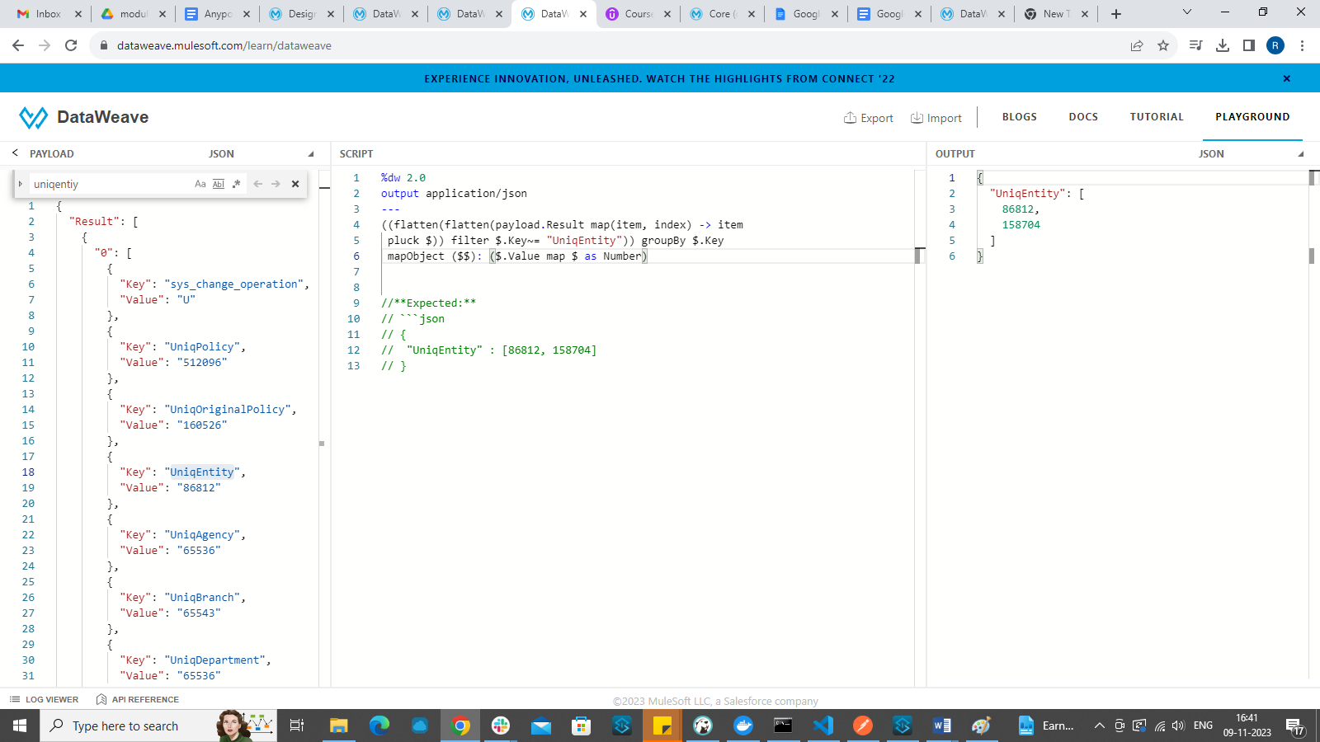

The payload here is an object inside which there is a result array of objects. It contains two objects inside the array with same keys but different values.

Here we need to fetch the value of a key named UniqEntity from the two objects in the array.

Payload.Result gives the returns the array payload and since the payload is an array, we will use map function to iterate over it.  
Pluck is used to transform object into an array.

pluck(Object<K,V>, (V,K,Number) -> T): Array<T>

We will filter based on the key name which is “UniqEntiy” using filter $.key ~= “key name”

Since we need both the values for the key, we use groupBy $.key

Then the output will be as shown

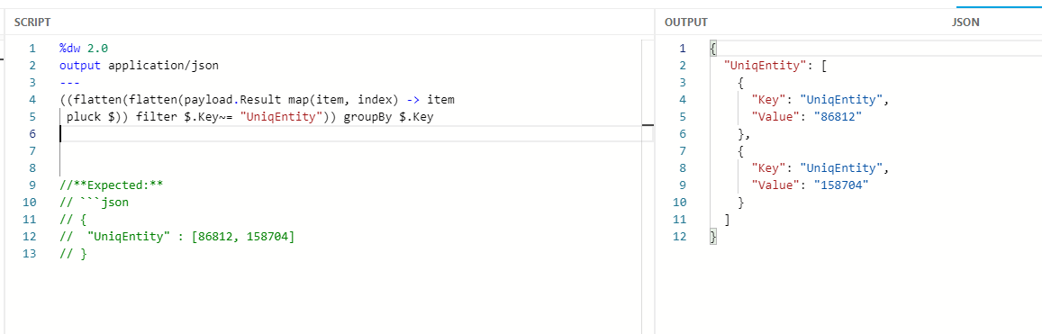

To get the output in required format we will be applying mapObject to the object obtained in the output.

We will combine both the values in a single array using map object and taking it as a number

mapObject ($$): ($.Value map $ as Number)

Which will give the expected output.